Physics 20 - Lesson 7H
Rotational Kinematics
/ 59
1)  /2 | The odometer is calibrated to a 70 cm wheel. If 60 cm wheels were used the odometer would read the distance traveled for the 70 cm wheel 70π = 220 cm for each revolution of the 60 cm wheel (actual distance = 188 cm). Therefore when the odometer reads 1.0 km traveled, only 0.86 km would have actually been traveled.
2)  /4 | 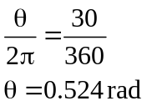 | 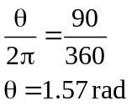 |  |  |  |  | 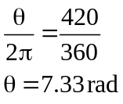
3)  /4 | θ  r  s |  |  | 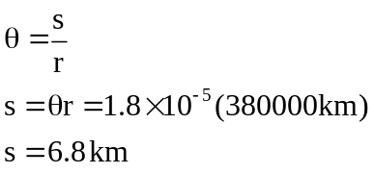
4)  /3 | 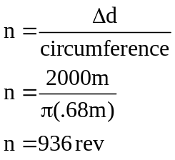
5)  /5 |  |  | a.  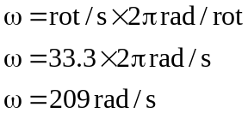  b.  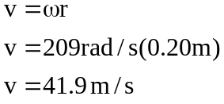
6)  /4 | 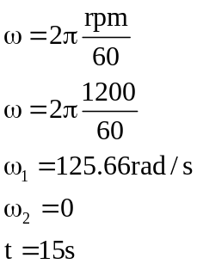 | 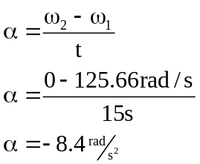
7)  /3 | 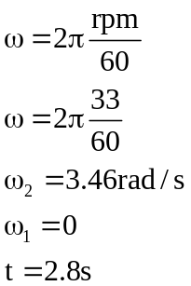 | 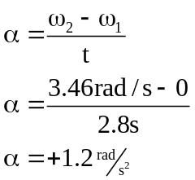
8)  /4 | Orbit around sun  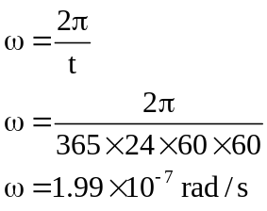 | About its axis  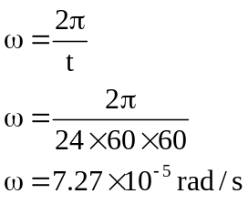
9)  /6 | 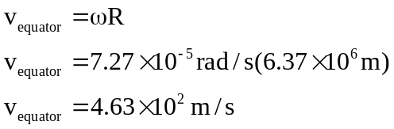 |  |  |  | θ  r  R  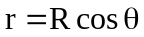
9)  /6 | 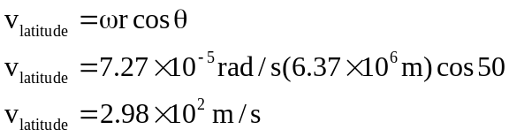

10)  /8 | 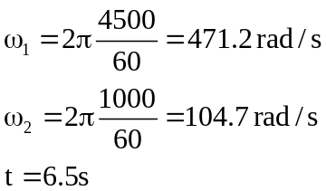 |  | 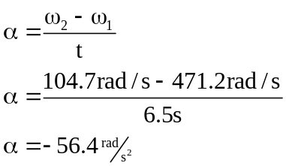  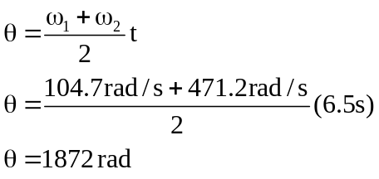  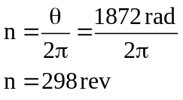
11)  /4 | 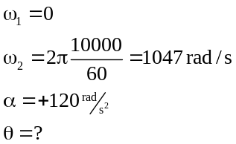 | 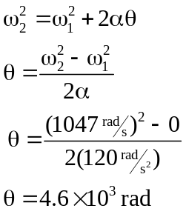
12)  /5 | 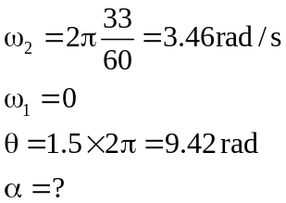 | 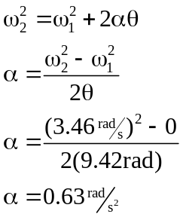
13)  /7 | 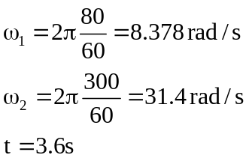 | Find angular displacement  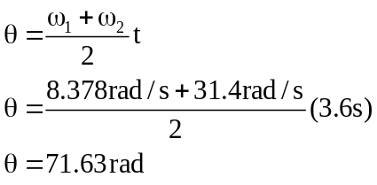 |  | Find s  